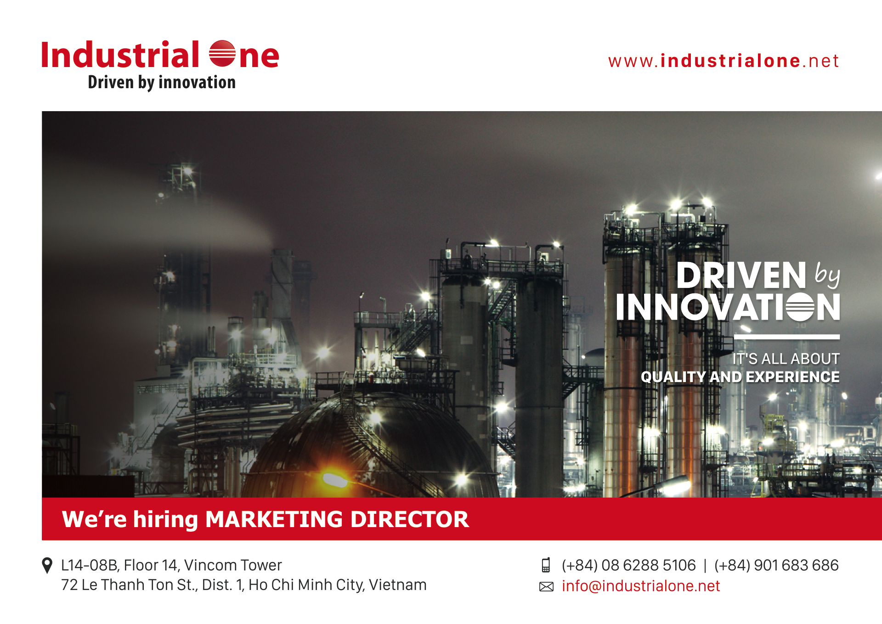
Hot Job: Marketing Director
What we can offer
- Salary: $US 4,500.
- Work location: Ho Chi Minh
- Healthcare insurance
- Report to GM
Company Info:
INDUSTRIAL ONE is a diversified technology company serving industrial customers and communities with innovative products and solutions. Headquarters in Saigon, Vietnam with research and development, manufacturing, sales, service, distribution center. Represent office in Jakarta – Indonesia and Yangon – Myanmar.
Our Vision
To be the world leader in providing industrial products & services with innovative solutions

Our Mission
We are innovating and leading through connections customers, employees and partners that benefit us all

Our Core Values
- Delivering on commitments
- Amplifying innovation and creativity
- Building relationships by open and honest communication
- Providing a great work environment
- Managing by facts

Industrial One Businesses
- Hydrogen Energy and Innovative Gas Solutions
- Air Compressor & Vacuum Pumps Solutions
- Wet Processing and Clean Room Solutions
- SMART Lighting Solutions
- Water Technology Solutions
- Hi –Tech Agriculture
- Industrial Mart : Industrial products, Electronics, Home & Living products

Job Title : MARKETING DIRECTOR

What we can offer
- Salary: $US 4,500.
- Healthcare insurance
- Profectional working environment
- Report to GM
- Work location: Ho Chi Minh

Job Description
- Building, determining and developing short-term and long-term strategies that are suitable for the company’s plan
- Planning entire marketing activities of the company to hand the Board of Directors such as Master plan including Trade, Digital, Communication, PR - events, Product Marketing and Creative Marketing.
- Managing, organizing performance, examining and evaluating the plan and the company's marketing activities.
- Planning and organizing and conduct market research.
- Analyze and position a brand and targeted customer in the market and drive long-term growth both.
- Managing the marketing budget in the assigned range.
- Human resource management and human resource development of the Marketing Department:
- Supporting Personnel organization department and giving decision making employment or arranging jobs consistent with the capacity of staffs.
- Training and developing staffs in the respective departments.
- Evaluating the result of work, proposing the reward and discipline for employees under the management division.
- Co-ordinating with other relevant departments to build the documents introducing about company; documents introducing the product line of the company; documents introducing new products; setting up plans and implementing training programs for household products, skills Center Sales and counselor of the sales stores and distributors.
- Co-ordinating with the marketing department of the company's partners to build and deploy the strategy / plan / marketing and solutions and communication for the product.
- Building and combining programs of after-sales service: customer care, Telesales…
- Conselling timely for the Board of Directors the sales policies, sales promotion for the company.
- Managing the organization of events of the company such as pressing conferences , launching new products and building relationships with media agencies.
- Coordinating with relevant departments to implement effectively marketing programs.

Job Requirement
- Male or Female 30-45 years old
- Having graduated formal national or international universities in sectors : Press, Marketing, Business Administration, Foreign Affairs
- Having experiences more than 5 years in the position : Marketing Director/Manager in the large company or group related to Industrial goods, Electronic and Home & Living products.
- Having good communication skills, confident and having ability working under high pressure
- Having creative personality and creating the differences
- Prefering the candidates working in the foreign companies or related to Household goods Companies in Vietnam
- Using Computer fluently and other sofwares serving for job.
Application:
Interested candidates kindly send us your updated CV to info@IndustrialOne.net , or contact +84 8 6288 5106 (Mr. Hung) for further detail and support.

Share this page

